Using the IF Discussion Approach in E-Discussions
Overview

Over the course of the semester we are going to continue our discussions by using the online discussion platform. Each week students will co-facilitate an exploratory discussion. The aim of these discussions is to better understand the subject matter through collaborative learning and divergent thinking.

Facilitation Schedule

Week 1, Dates, Name 1 and Name 2, Topic TBD
Week 2, Dates, Name 1 and Name 2, Topic TBD
Week 3, Dates, Name 1 and Name 2, Topic TBD
Week 4, Dates, Name 1 and Name 2, Topic TBD
Week 5, Dates, Name 1 and Name 2, Topic TBD
Week 6, Dates, Name 1 and Name 2, Topic TBD
Week 7, Dates, Name 1 and Name 2, Topic TBD

The Process

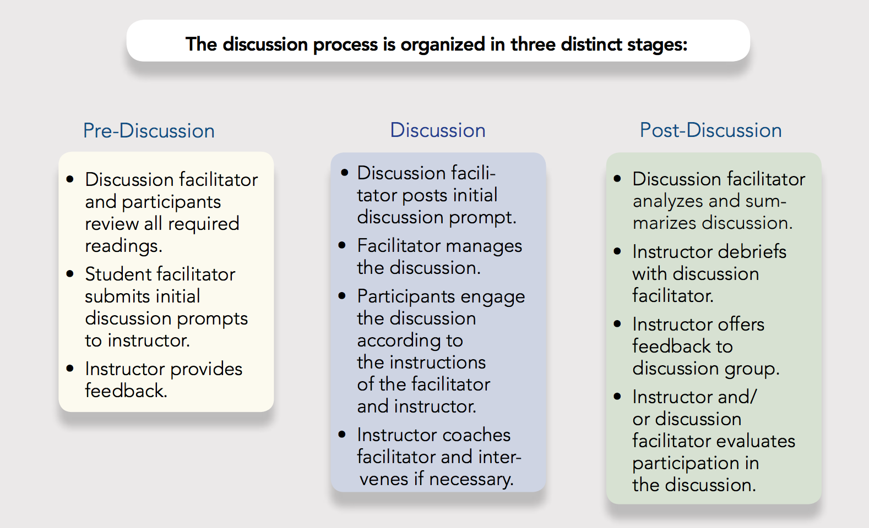

The Discussion Facilitator

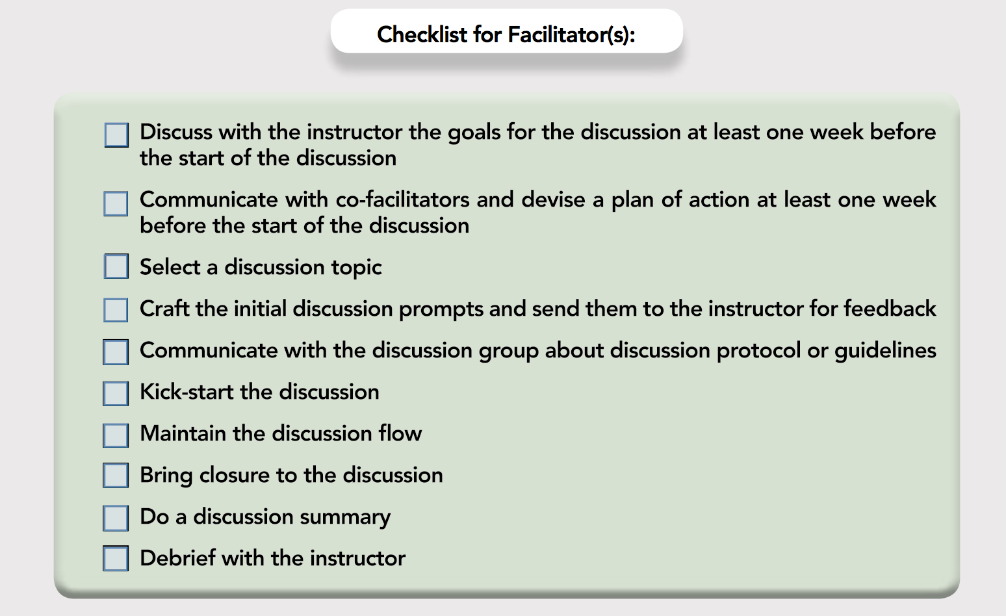

As we have already mentioned elsewhere, the role of facilitator is not to teach or lead discussants to a particular conclusion. The IF Discussion approach seeks out divergent thinking through “surrounding the topic” (see handout) and encourages participants to assume the perspective of others.

For a more detailed account on how to facilitate exploratory discussion online, please refer to
The Guidebook for Student-Facilitated Discussion in Online Courses, Student Edition

The Discussion Participant

Participating in an online discussion is not always as simple as it seems. Oftentimes the process feels unrewarding. Discussants post one-off statements and rarely do they respond to or build on the ideas of others. We have developed a high standard of participation in online courses. For example, in our process the role of the discussant is to:

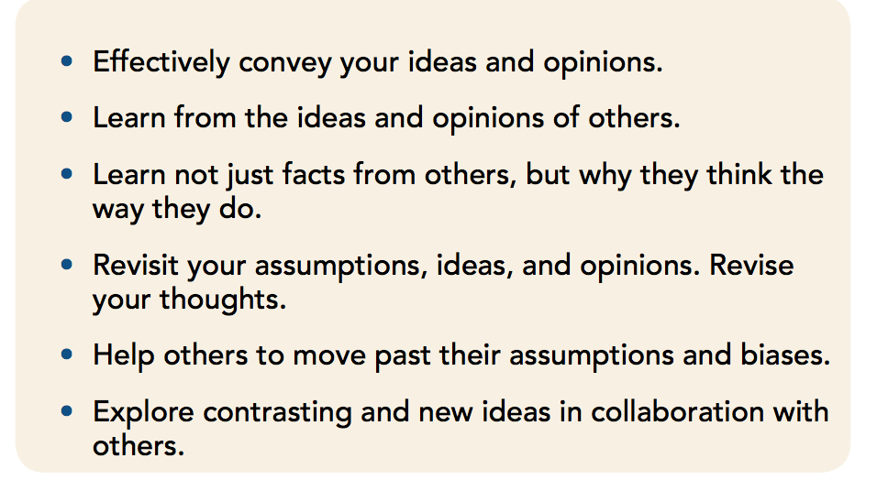

What can discussion participants do to help achieve these goals?

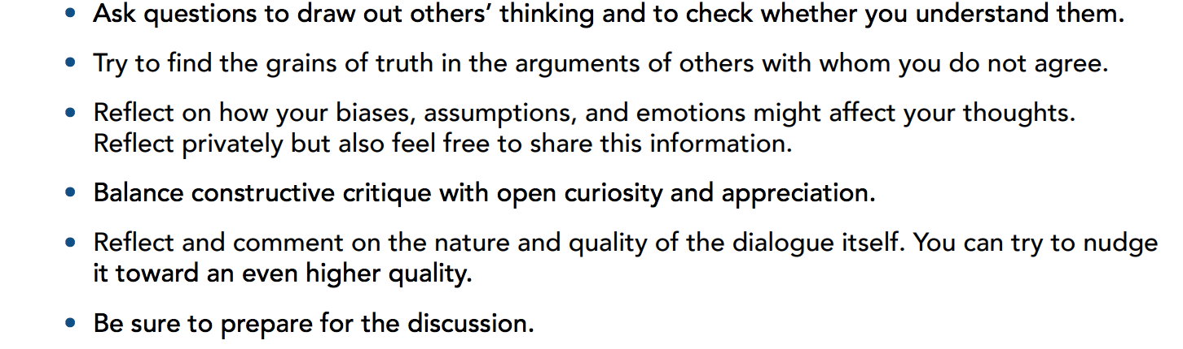

How do you craft a good discussion post?

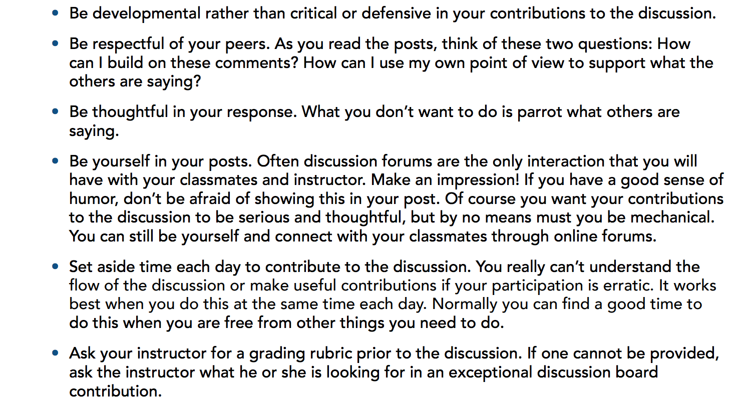

If you would like to know more about how to incorporate student-facilitated discussions into your classroom, and you’d like to see these grading rubrics, check out:

The Guidebook for Student-Facilitated Discussion in Online Courses, Instructor Edition

